M02 Quality Policy

We have established this quality policy to be consistent with the purpose and context of our organization. It provides a framework for the setting and review of objectives in addition to our commitment to satisfy applicable customers’, regulatory and legislative requirements as well as our commitment to continually improve our management system.

Customer focus: As an organization, we have made a commitment to understand our current and future customers’ needs; meet their requirements and strive to exceed their expectations.

Leadership: Our Top Management have committed to creating and maintaining a working environment in which people become fully involved in achieving our objectives.

Engagement of people: As an organization, we recognize that people are the essence of any good business and that their full involvement enables their abilities to be used for our benefit.

Process approach: As an organization, we understand that a desired result is achieved more efficiently when activities and related resources are managed as a process or series of interconnected processes.

Improvement: We have committed to achieving continual improvement across all aspects of our quality management system; it is one of our main annual objectives.

Evidence-based decision making: As an organization, we have committed to only make decisions relating to our QMS following an analysis of relevant data and information.

Relationship management: STI recognizes that an organization and the relationship it has with its external providers are interdependent and a mutually beneficial relationship enhances the ability of both to create value.

Our policy is also to meet the requirements of other interested parties and in meeting our social, environmental, charitable, regulatory and legislative responsibilities.

We have produced quality objectives which relate to this policy and they can be found in document R03 Quality Objectives.

This policy is available/communicated to all interested parties as well as being made available to the wider community through publication on our Website, Company Bulletin Board and Intranet.

Authorized by: 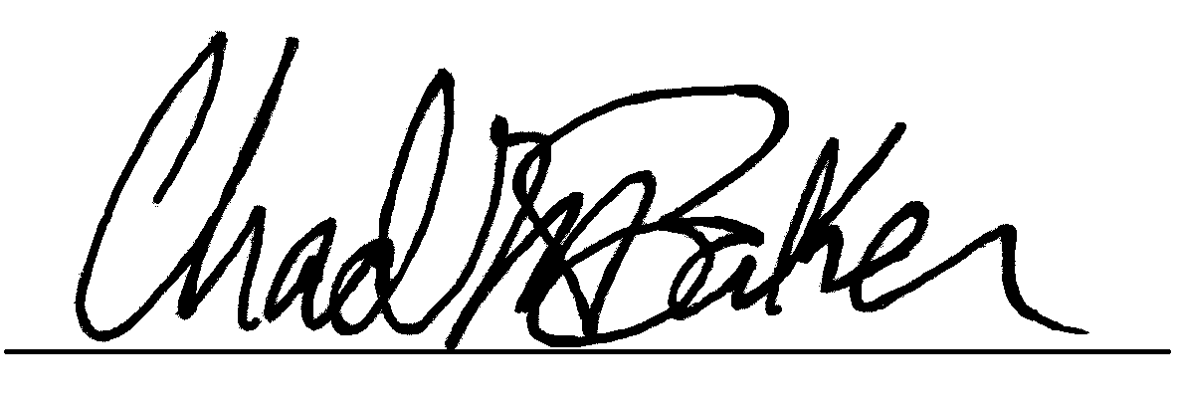 Position: General Manager

Date Approved: 2/17/22

Review Date: 1/26/22

